DIMORA’S FREE DOWNLOAD LIBRARY BELOW up-dated May 4, 2026


FREE


July 28, 2026 Edition of The Last Chronicles of Planet Earth click link below.

https://endtimesresearchministry.com/wp-content/uploads/2026/07/The-Last-Chronicles-of-Planet-Earth-July-28-2026-Edition-by-Frank-DiMora-2.pdf

Free download: https://endtimesresearchministry.com/ezekiel-38-war-just-ahead/
FOR SPANISH SPEAKING READERS
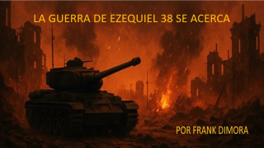
https://endtimesresearchministry.com/la-guerra-de-ezequiel-38-se-acerca-copy/

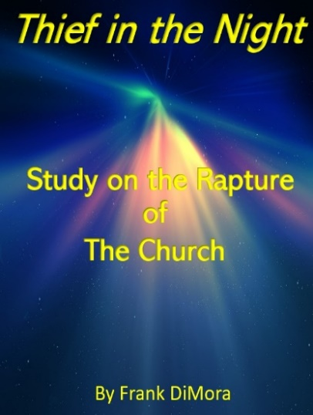Free Download
https://endtimesresearchministry.com/thief-in-the-night-study-on-the-rapture-of-the-church-by-frank-dimora/
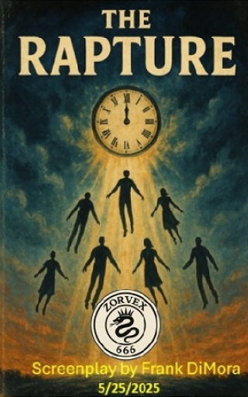
Free Download
https://endtimesresearchministry.com/the-rapture-screen-play-may-25-2025-written-by-frank-dimora-3/

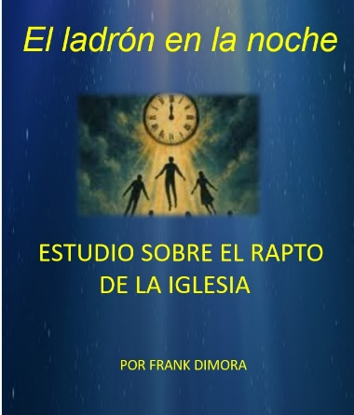 Free Download
https://endtimesresearchministry.com/estudio-sobre-el-rapto-de-la-iglesia-por-frank-dimora/

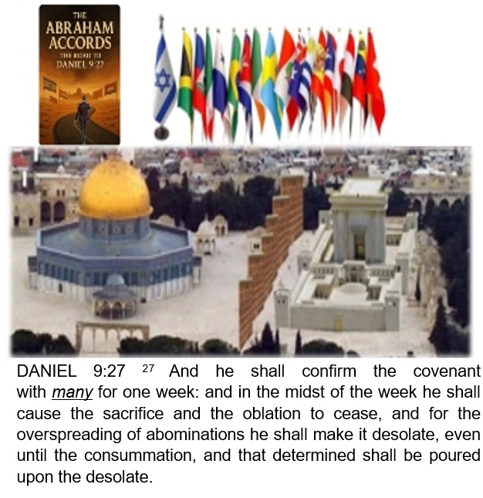

Free Download
https://endtimesresearchministry.com/the-warning-from-ezekiel-43-concerning-the-temple-mount-plus-the-abraham-accords-copy-2/

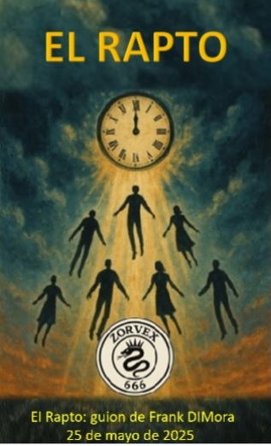
FREE Download
https://endtimesresearchministry.com/el-extasis-obra-de-pantalla-de-frank-dimora-5-de-septiembre-de-2025/

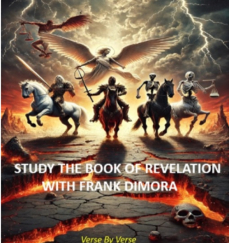
FREE
https://endtimesresearchministry.com/book-of-revelation-verse-by-verse-2025-with-frank-dimora/
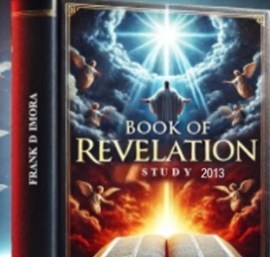
FREE
If anyone would like to study the book of revelation I did in 2013, you can find my teachings at the link below. This is a video study.
https://www.youtube.com/playlist?list=PLhzaiuM2IiTo0M0N3DiMe0dyfuq13Xcn9
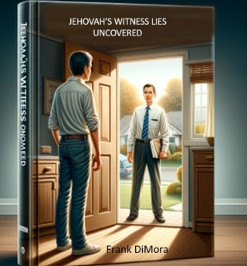
When the Jehovah’s Witnesses come knocking on your door, you really need to know who it is that is knocking! Let me show you where the angels came from that the Watchtower Society says are guiding them? With the right answers you can help a Jehovah witness see the truth!
For years, I have conducted in-depth research into the teachings of the Watchtower Society of Jehovah’s Witnesses. Sadly, the average Jehovah’s Witness never questions or investigates what their leaders teach. As a result, they remain unaware that many of these teachings have been influenced by Satan and his angels, who—according to the Watchtower’s own claims—are guiding their organization.
If you are a new Jehovah’s Witness, I urge you: what I present in this paper is exactly what the Watchtower doesn’t want you to see. Using the Watchtower’s own publications and documents, I will show you that Satan is behind the organization’s teachings.
Jehovah’s Witnesses are sincere, well-meaning people who have been led away from the true teachings of God. And because we are living in the last days, it is more urgent than ever for you, as a Jehovah’s Witness, to examine what your leaders have hidden from you.
Click the link below to see how Satan has influenced the Watchtower organization. Your eternal destiny is at stake. Your soul depends on whether you are willing to ‘make sure of all things.’ If you never examine your own teachings, you cannot claim to have truly ‘made sure of all things’—and you cannot honestly call yourself one of Jehovah’s Witnesses.
FREE Download: https://endtimesresearchministry.com/the-truth-behind-the-jehovah-witness-organization-by-frank-dimora-1/
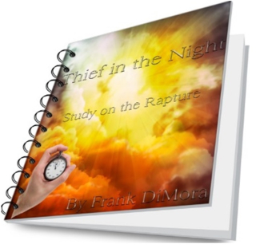
Read Chapter 21 of my book The Rapture of the Church.
What did Jesus mean when He gave this warning in 2 Thessalonians 2:11?
"And for this cause God shall send them strong delusion, that they should believe a lie."
This verse is set in the context of those who refuse to believe the truth of the Gospel and instead choose to embrace falsehoods and deception. It reveals that God allows—or permits—a powerful delusion to overtake those who reject the truth, leading them even deeper into lies. This is understood as a form of divine judgment, a consequence for their willful rejection of God’s truth.
Could it be possible that when the Church of Christ is raptured and taken to heaven, the “strong delusion” will be the lie that those missing were taken by aliens—and that those left behind are actually the “good” people? When, in reality, the opposite is true?
See the link below for more insights on the rapture.

MY LETTER TO YOU IF YOU MISS THE RAPTURE
FREE
https://endtimesresearchministry.com/wp-content/uploads/2025/10/MY-LETTER-TO-THOSE-WHO-ARE-LEFT-BEHIND-WHEN-JESUS-RAPTURES-HIS-CHURCH-1.pdf

If you choose to reject Christ's love and his salvation please watch this very short video. Don't blame Christ for where you spend eternity, it’s you who choose where you go.

HELL video
https://www.youtube.com/watch?v=o9TYuEgCThI
